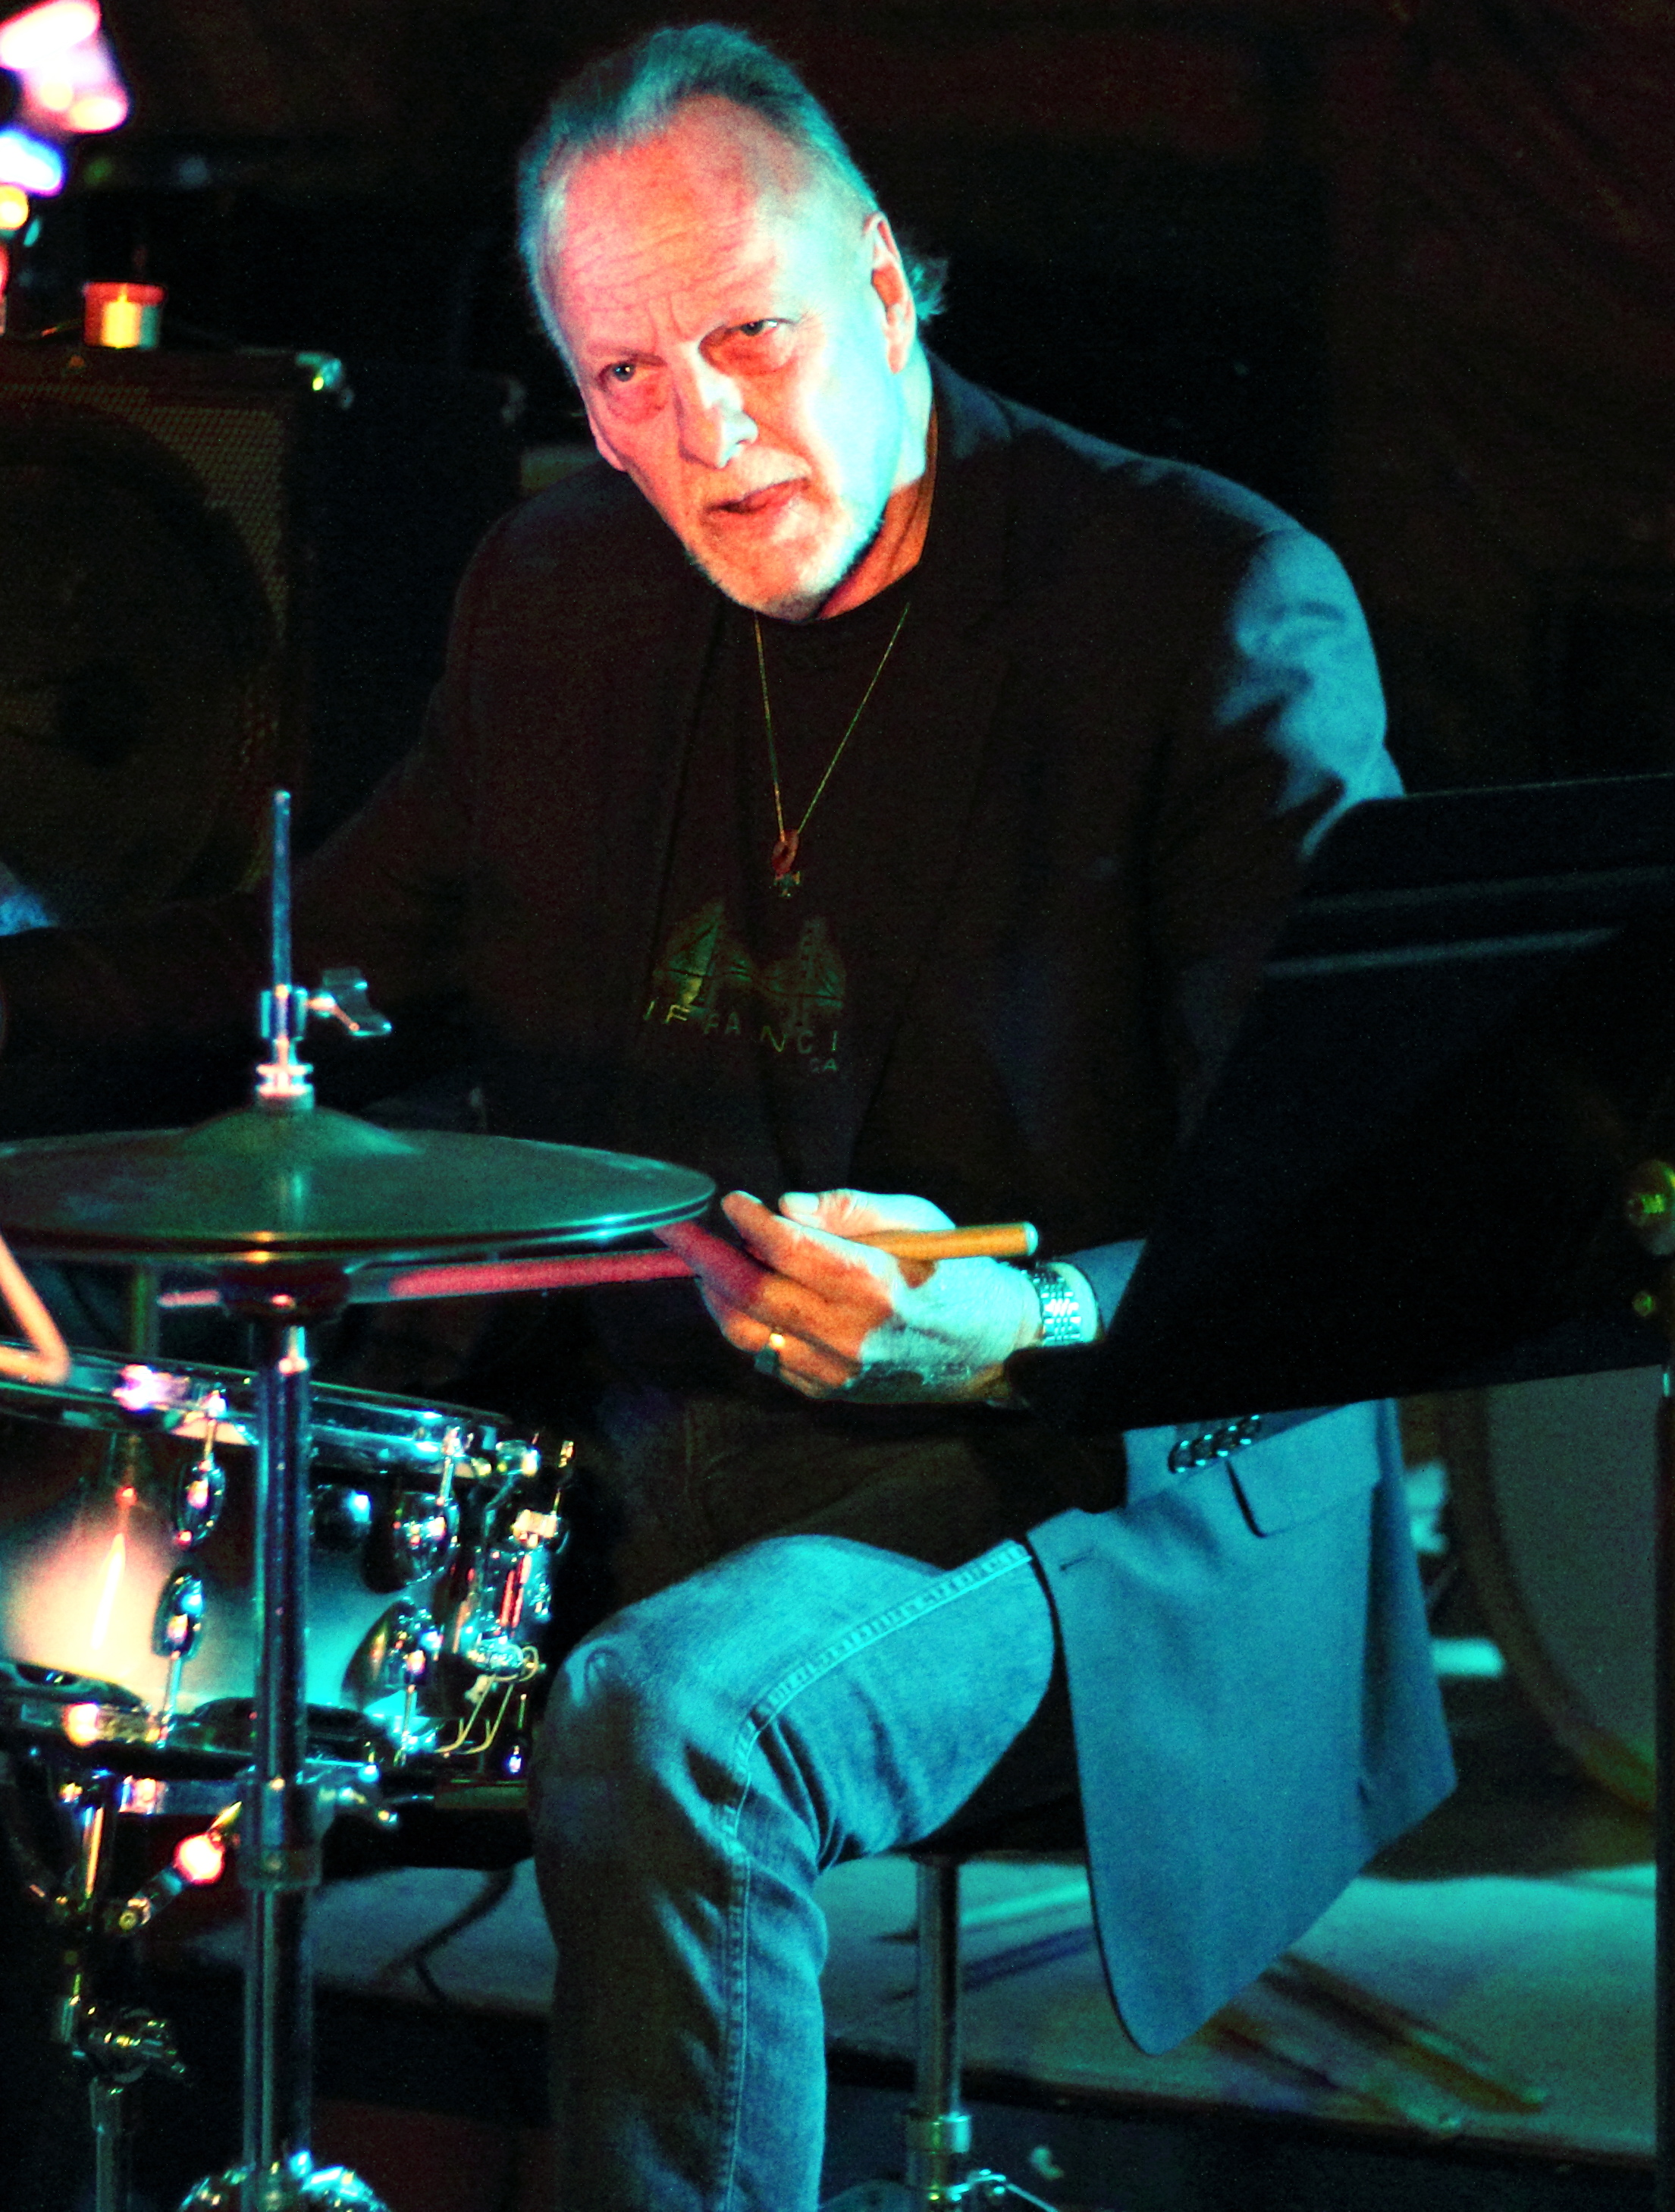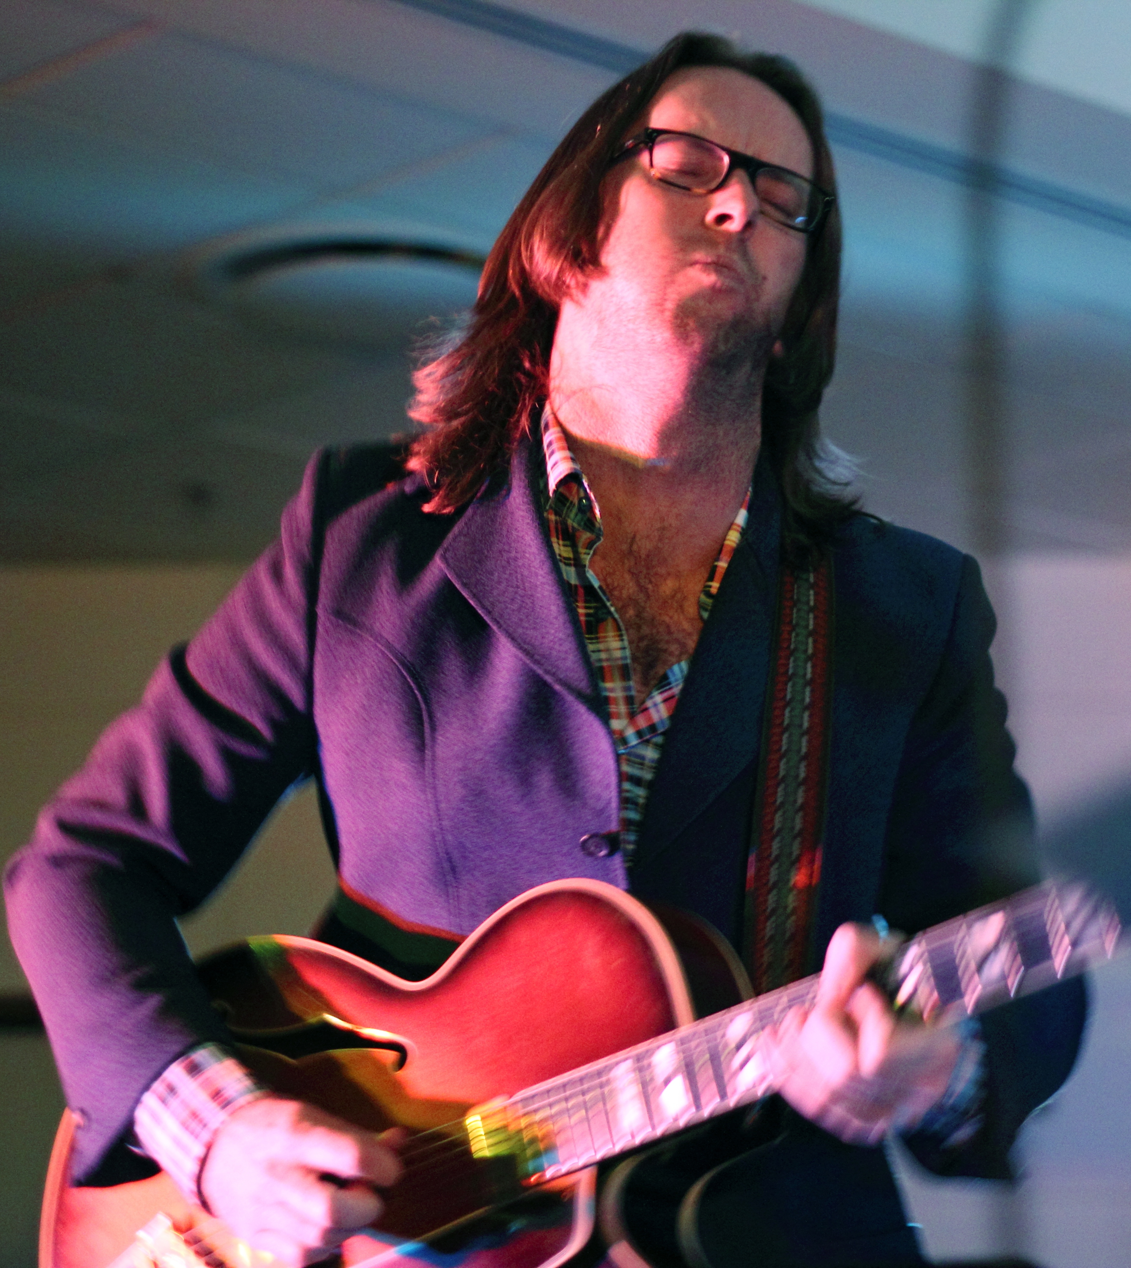
“This pair are particularly well matched and their ability to capture the mood and vibe in a fresh way makes for a great night out.” – Jazz journalist John Fenton, www.jazzlocal32.com

4
WHAT:

Drumming icon Frank Gibson and guitarist Neil Watson have been performing together as a duo for the last seven years. Playing this long at their C.A.C bar residency in Mt Eden has allowed them to develop a unique and instinctive musical exchange that only time like this could evolve. The openness of this duo format lends itself to infinite possibilities of musical dialogue that these two can chew the fat on for hours. Gibson and Watson perform a rag-tag of jazz from nearly every era and spectrum along with interpretations of pop and folk classics, free improvisations and groove. Their repertoire stretches the whole gammit from Morton to Monk, Marley and more. All of this is executed with their own identifiable sound and contemporary swagger.
WHO:

Frank has had a vast career that has taken him around the world. He is recognised in the international Jazz community as an icon and fantastic player. He is one musician who could play with any jazz group in the world and has shown his ability to play in any genre due to his wonderful feel, outstanding technique, and great empathy. All of this has given Frank a very successful career. His CV reads like the "Who's Who" of jazz and he has played with many artists from Frank Foster, John Scofield to Alan Broadbent, Joe Henderson to Sam Rivers.

With close to twenty years experience as a professional musician, performer and music tutor, Neil continues to perform and record with a huge array of national and international artists spanning a wide variety of musical genres. He has performed with jazz masters such as Michael Brecker, Diane Shuur and Mike Nock along with pop artists such as The Finn Brothers, Anika Moa and Randy Crawford. Along with his many sideman duties, recording and TV session work he continues to develop his unique hybrid style as a solo artist through varying performances, practices, recordings and line-ups.

LOOK & LISTEN:

https://www.youtube.com/watch?v=TsQk2A_WYmE

https://www.youtube.com/watch?v=YLw2zL1UUOk

https://soundcloud.com/neil_geetar_watson/careful

https://soundcloud.com/neil_geetar_watson/my-fair-young-love-1

CONTACT:

Neil Watson 021-376556, whawhawatson@xtra.co.nz, www.neilwatson.co.nz

